Alexander Baldree
10/01/26
Module 11.2 Assignment
CSD440

GitHub Link:
https://github.com/Panda-Alex21687/CSD440

AlexPDF.php:
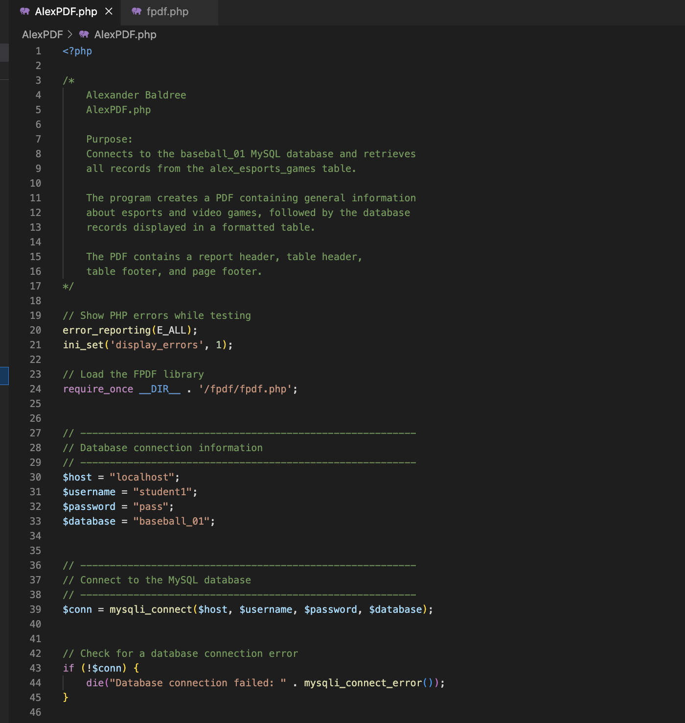

PDF:
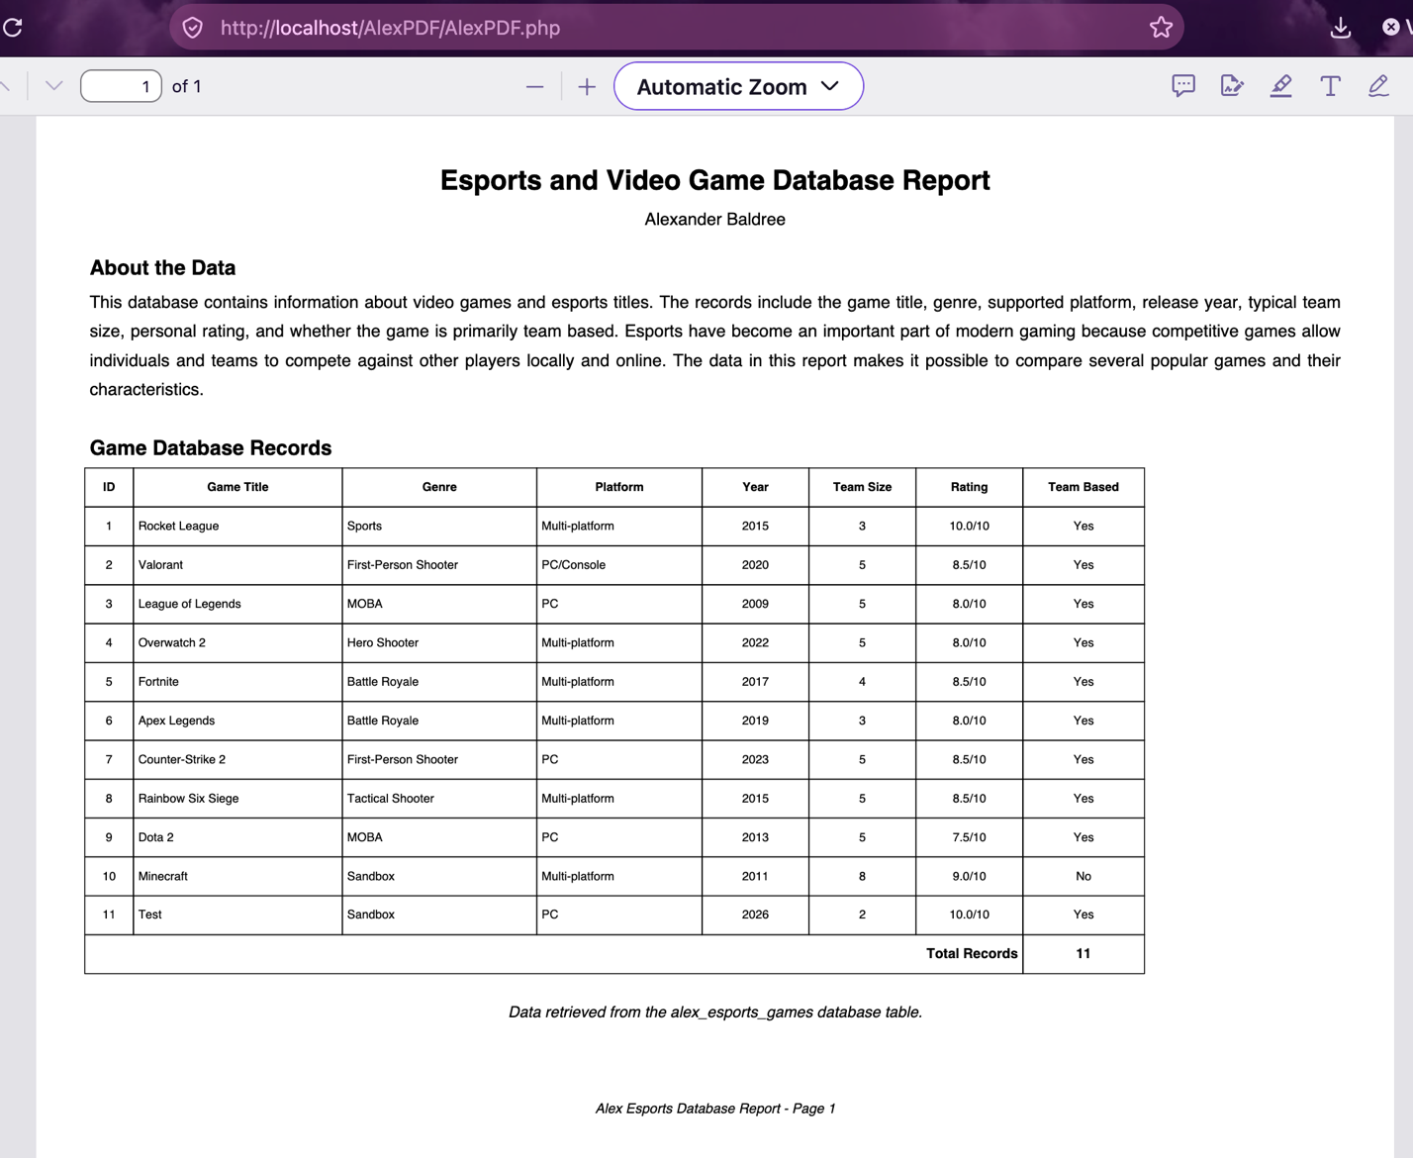

Database Table:
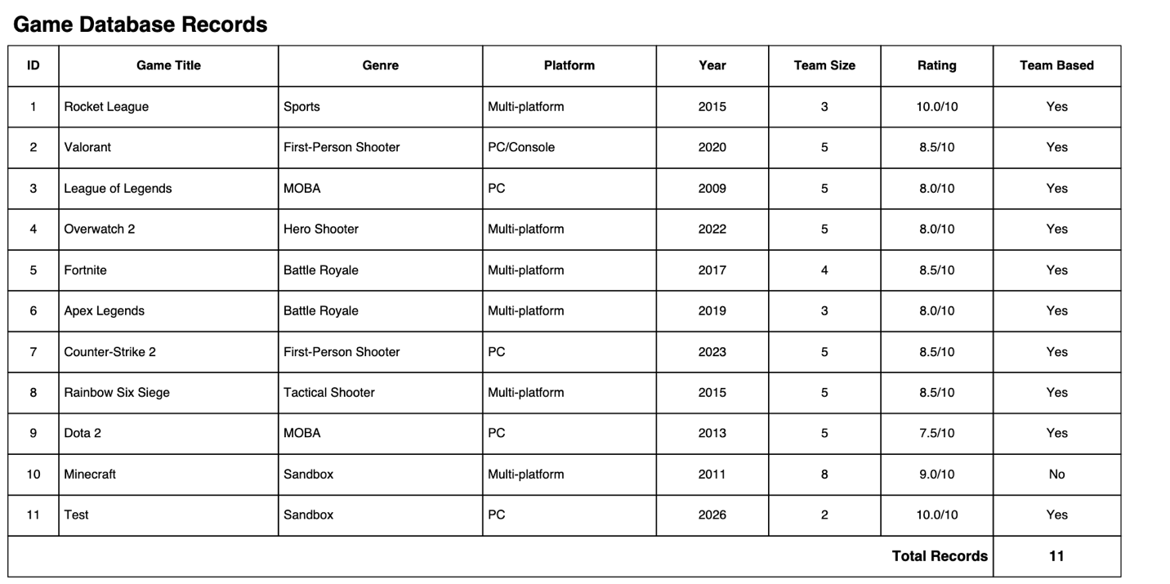

Footer of PDF:
